**ARAVINDH.M**

**ASSIGNMENT-15**

**TOPIC: RANDOM FORESTS**

**QUESTIONS:**

**Use Random Forest to prepare a model on fraud data treating those who have taxable_income <= 30000 as "Risky" and others are "Good"**

**DATASET:Fraud_check**

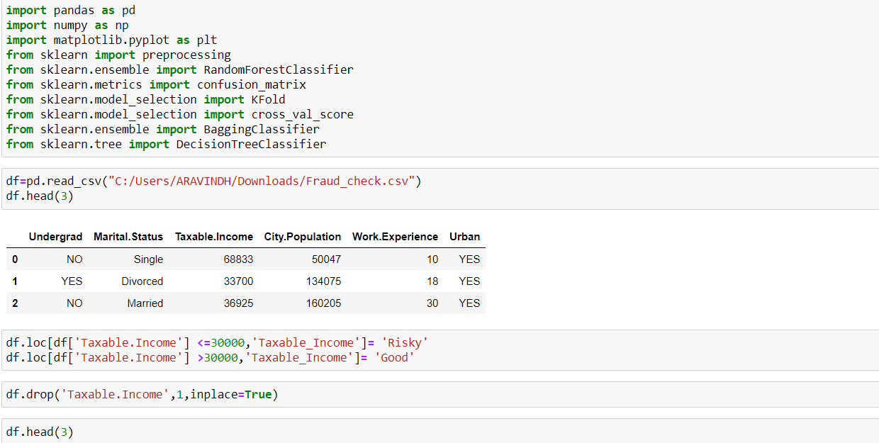

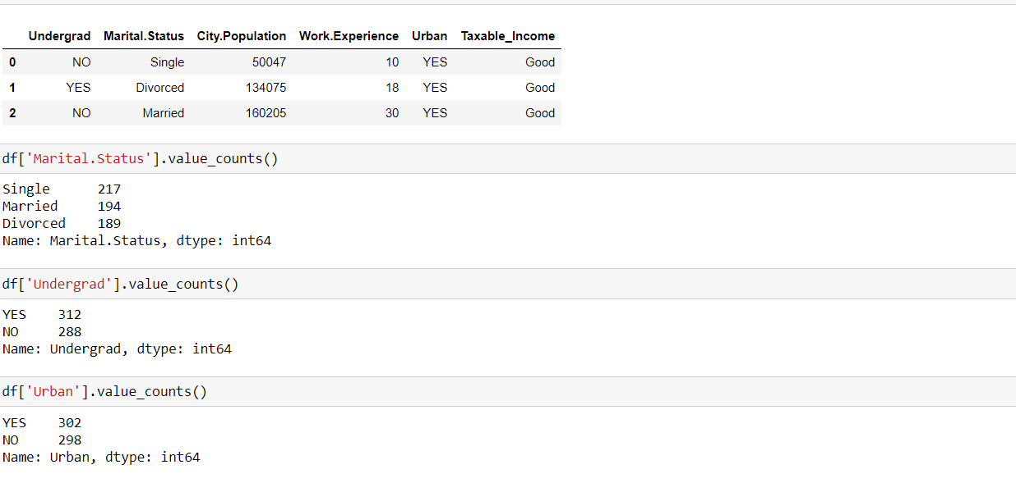

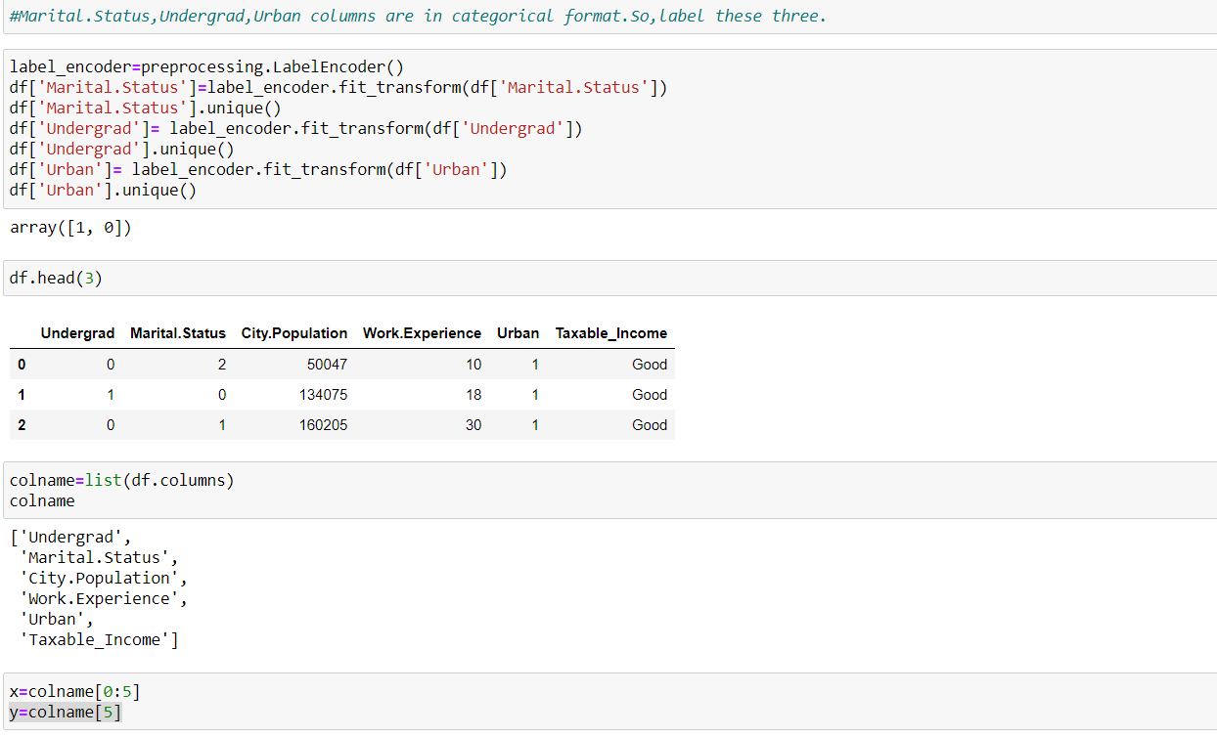

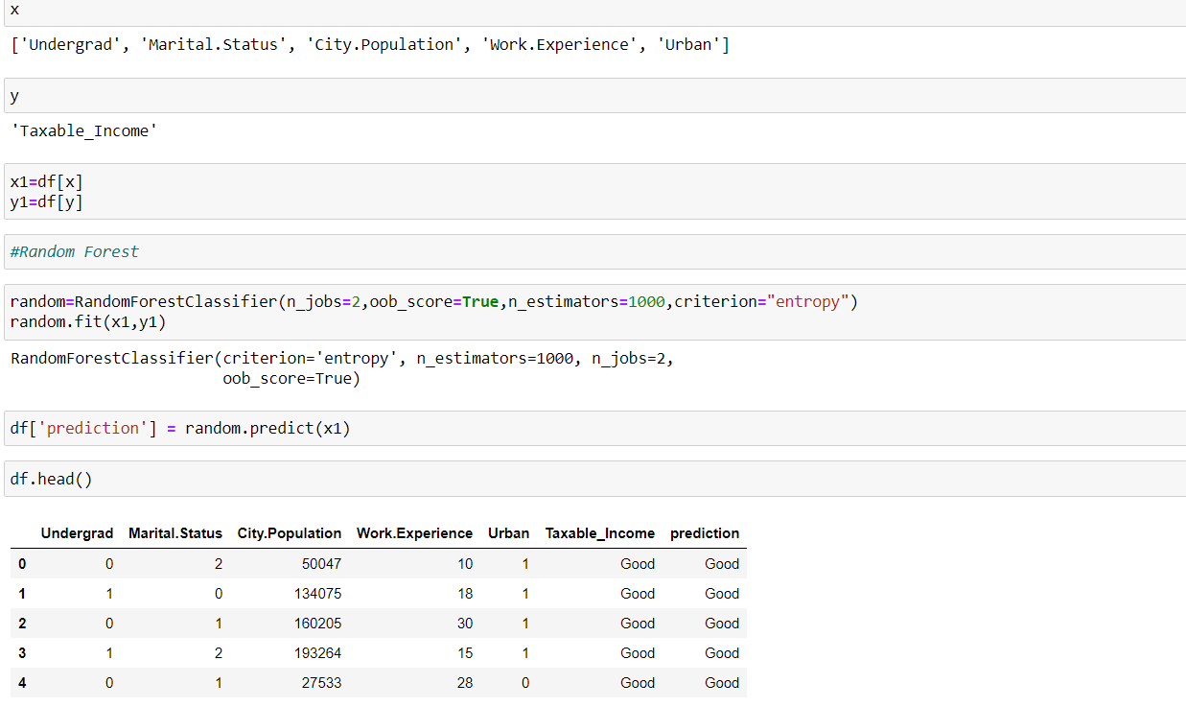

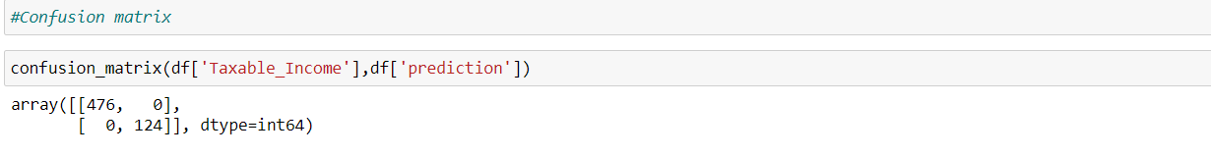

**BAGGING:**

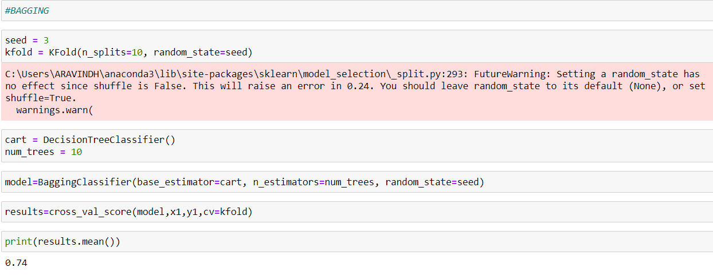

**ADABOOST:**

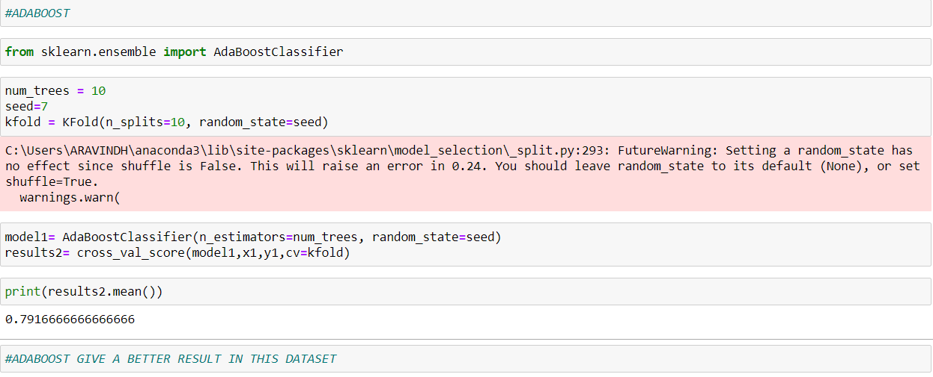

**QUESTION:**

**A cloth manufacturing company is interested to know about the segment or attributes causes high sale. Approach - A Random Forest can be built with target variable Sales (we will first convert it in categorical variable) & all other variable will be independent in the analysis.**

**DATASET:Company_Data**

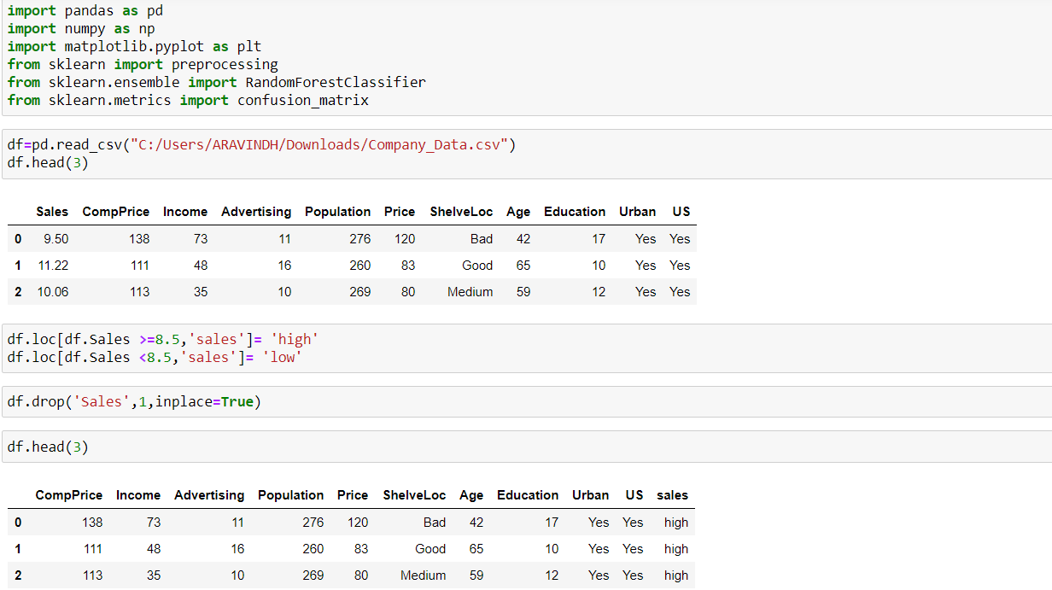

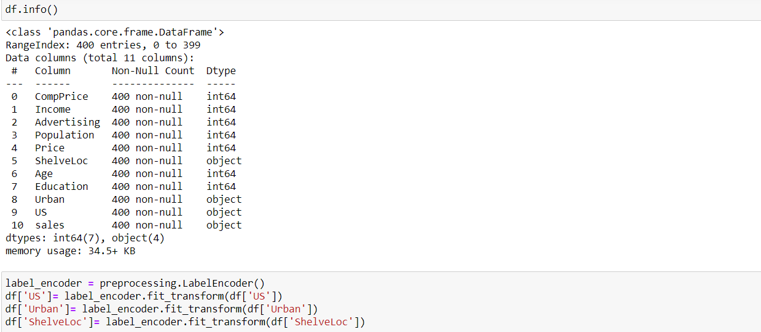

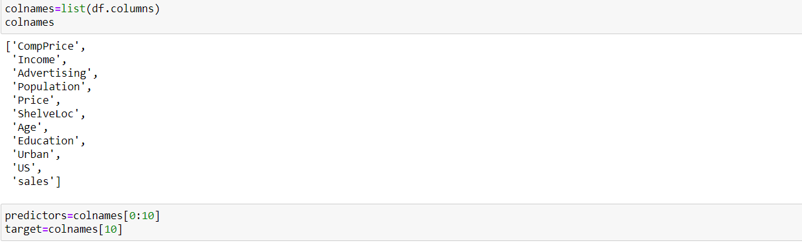

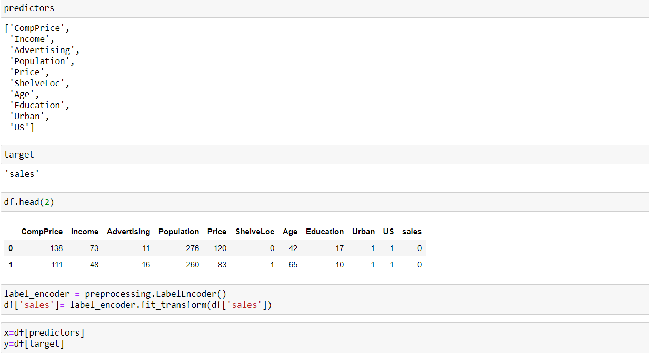

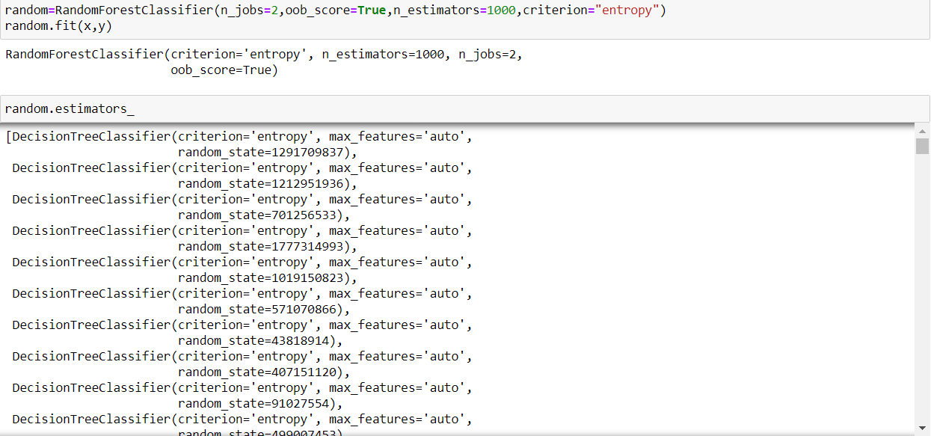

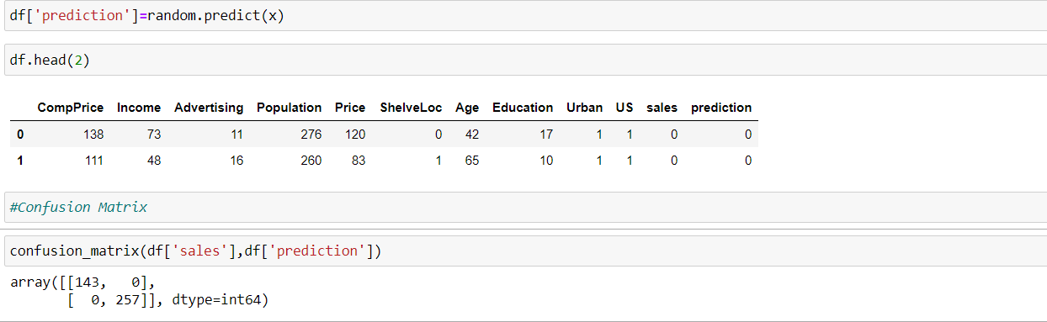

**BAGGING:**

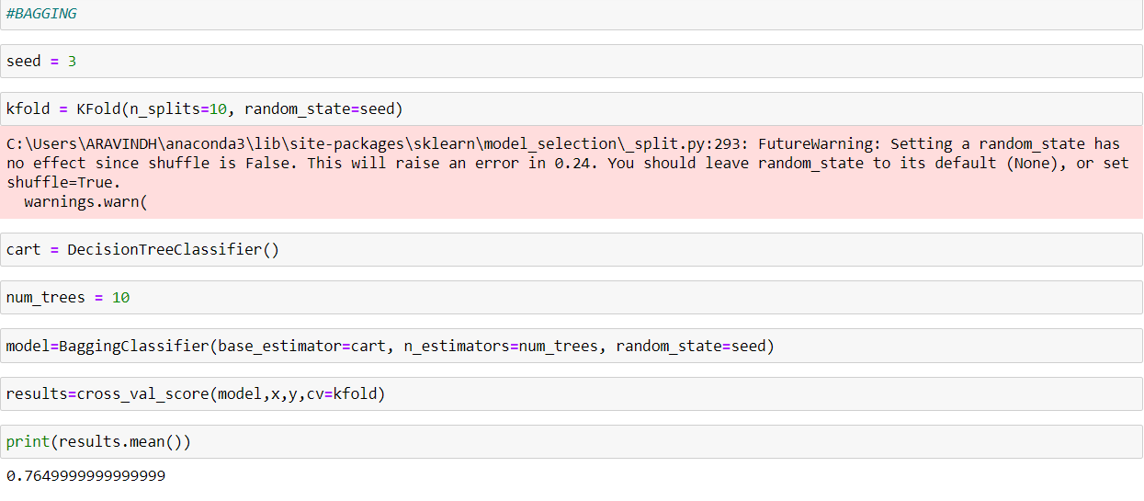

**ADABOOST:**

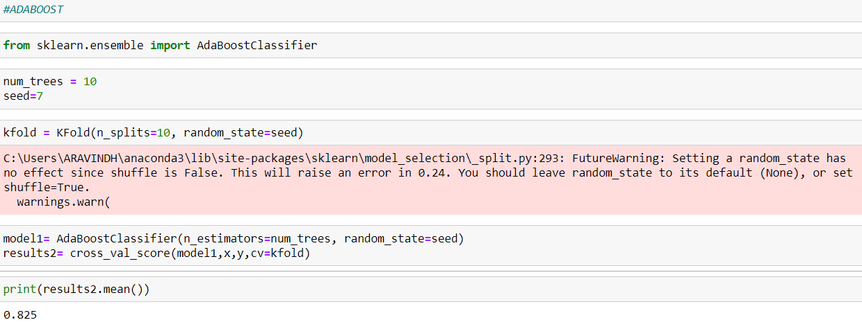

**QUESTION:  
Perform the following activity in R: → Build a random forest for the ‘iris’ data.**

**DATASET: Iris**